Object-Oriented Programming
Lab

SPRING 2026

LAB 02



FAST National University of Computer and Emerging Sciences

Learning Outcomes

In this lab you are expected to learn the following:

• Pointers
• Dynamic Memory Allocation (1D Array)
POINTERS

A pointer is a variable that stores an address of a memory location.

Pointer Declaration and initialization
Pointers is declared as follow.

Type* <variable Name>;

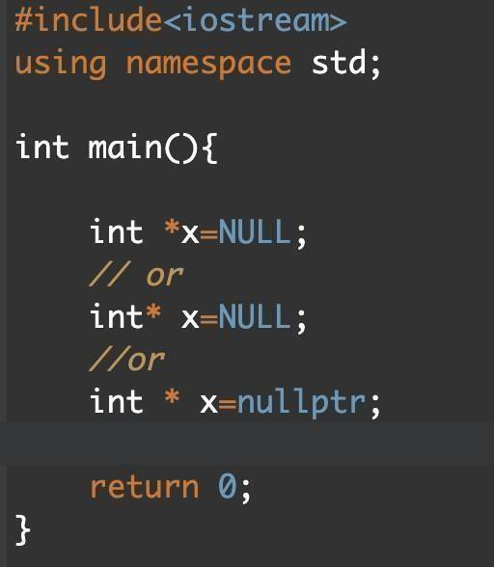

Address-of operator (&)

The ampersand, &, called the address of operator, is a unary operator that returns the address of its operand.

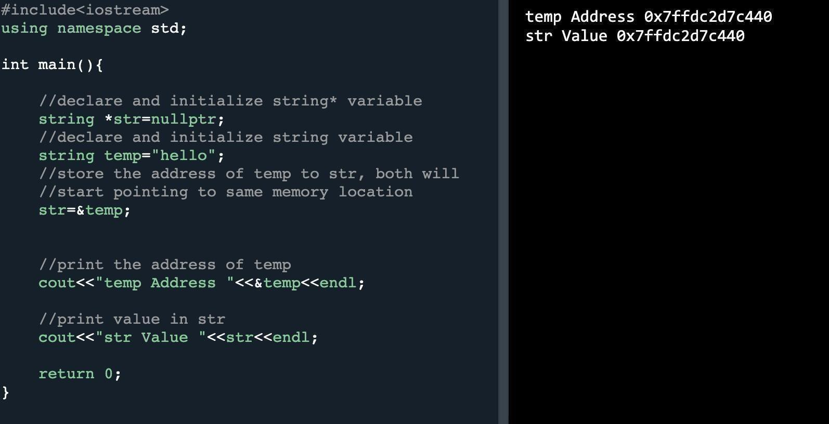

Dereference operator (*)

The unary operator * is the dereferencing operator that returns the value of its operand.

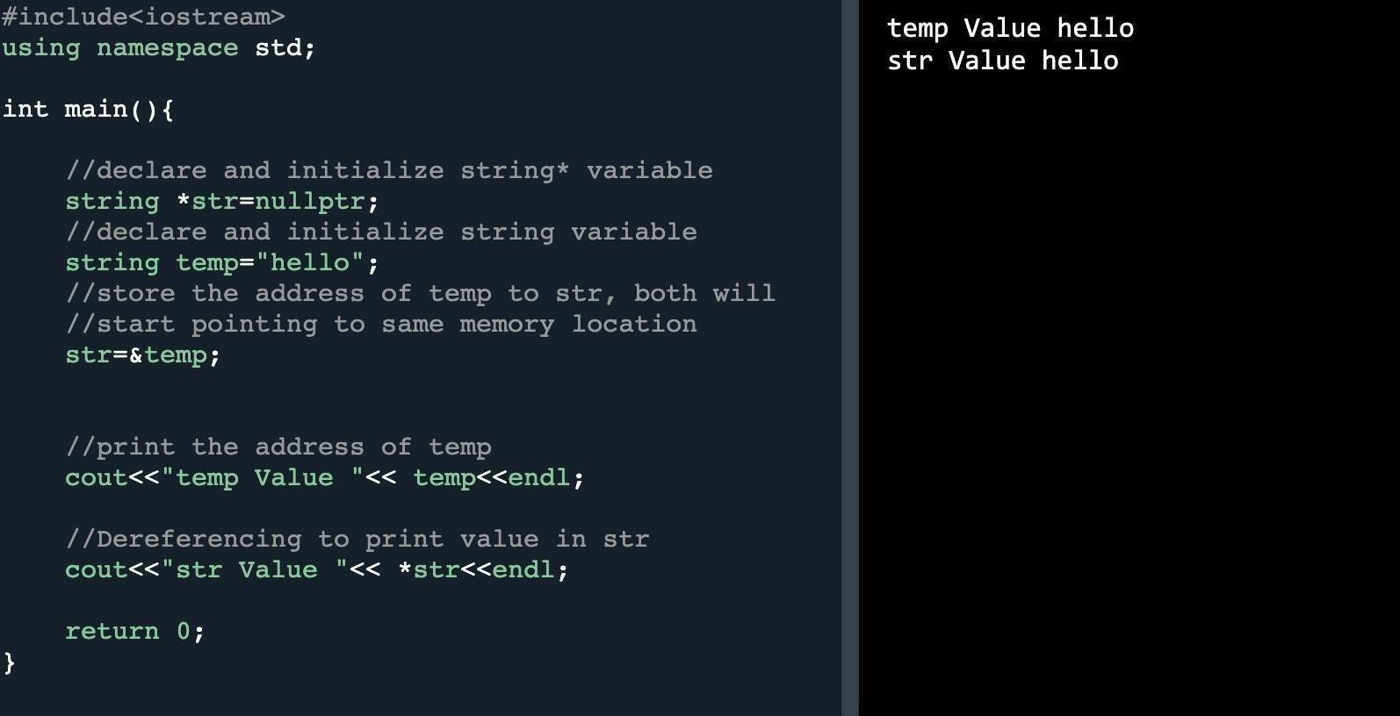
Array manipulation using pointer

The identifier of the array is a constant pointer. The elements of the array can be accessed using dereferencing in the following manner.

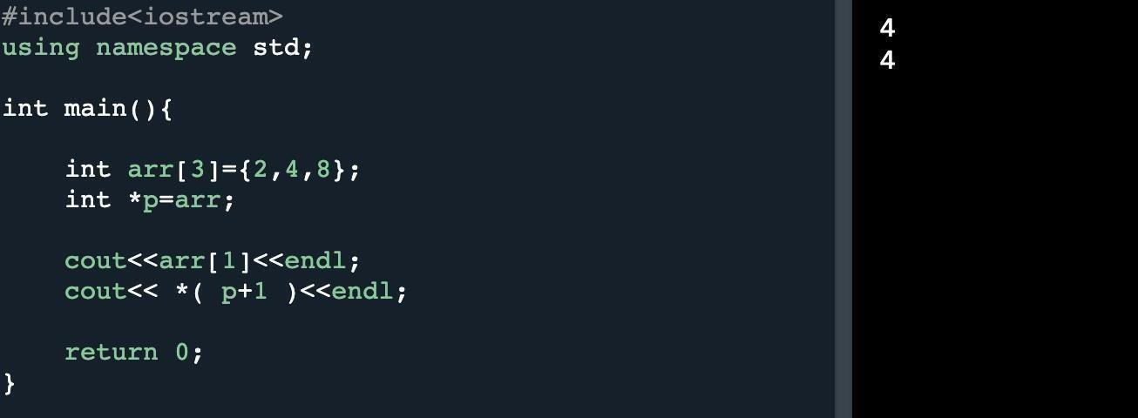

Problem 1.

Write a C++ program to dynamically allocate memory for a string. The program should find the word in the string that has the highest number of repeated letters. Ensure you use 1D dynamic memory allocation for the input string and deallocate the memory properly.

Example:

Input: "Print a welcome text in a separate line."

Output: "Word which has the highest number of repeated letters: separate"

Function Prototype: int countRepeatedLetters(char* word)

Problem 2.

Given the string "A string." Print on one line the letter on the index 0, the pointer position and the letter t. update the pointer to pointer +2. Then, in another line print the pointer and the letters r and g of the string (using the pointer).

Function Prototype: char printAndUpdatePointer(char* inputStr)

Problem 3.

Write a function named calculateGardes which takes an array and its size as function parameters. You are required to apply following grading policy. Note: You have to release the memory using the delete operator before the end of the program.

Function Prototype: char *calculateGrades(int arr[ ],int size)

Score Grade
91-100 | A
76-90 | B
60-75 | C
51-59 | D
Below 50 | F

Problem 4.

Write a function named as sortArray which takes an array and its size as function parameters, you are required to sort the array such that odd numbers come first and then even numbers. Odd and even values should be reordered within their interval i-e in the example given below if 6 comes before 4 in original array, it must be sort in the sorted array. Use pointer notation to solve this problem.

Function Prototype: int* sortArray(int *arr, int size);

Example:

Input: a=6, 3, 1, 2, 7, 5, 9, 4; Output: a=1, 3, 5, 7, 9, 2, 4, 6;

Problem 5:

You are given an array A of N integers. You want to choose some integers from the array subject to
the condition that the number of distinct integers chosen should not exceed K. Your task is to maximize the sum of chosen numbers. Print the maximum sum you can obtain by choosing some elements such that the number of distinct integers chosen is at most K. If you cannot choose any element, output 0.

Note: You need to implement the main for this problem by taking values of the array as input from the user.

Function Prototype: int maximizeSumWithKDistinct(int * arr, int size, int k);

Example

Input

K=2, Array=2, 1, 2, 5

Output: 9

Explanation

we have N=4, K=2, A=[2,1,2,5] . We need to choose atmost 2 distinct integers, we choose 2,2,5. Note that the condition is choosing atmost distinct integers. So we can choose repeated number as many times as we want. The sum is 2+2+5=9 and we output it.

Submission Instructions:

• Create a new folder with the name ROLLNO.zip e.g. i25XXXX.zip.
• Move your .h and .cpp files to this newly created directory and compress them into a .zip file.
• Now you have to submit this zipped file on Google Classroom.
• If you don’t follow the above-mentioned submission instructions, you will be marked zero.
• Plagiarism in the Lab Task will result in zero marks in the whole

